# Number Systems Class 9 Extra Questions Maths Chapter one

## Number Systems Class 9 Extra Questions Maths Chapter 1

****Extra Questions for Class 9 Maths Chapter 1 Number Systems****

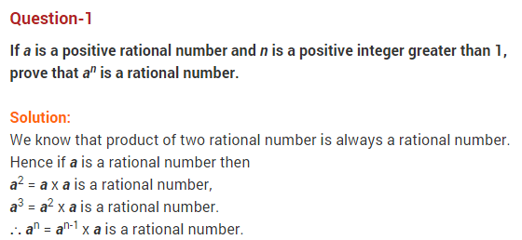  
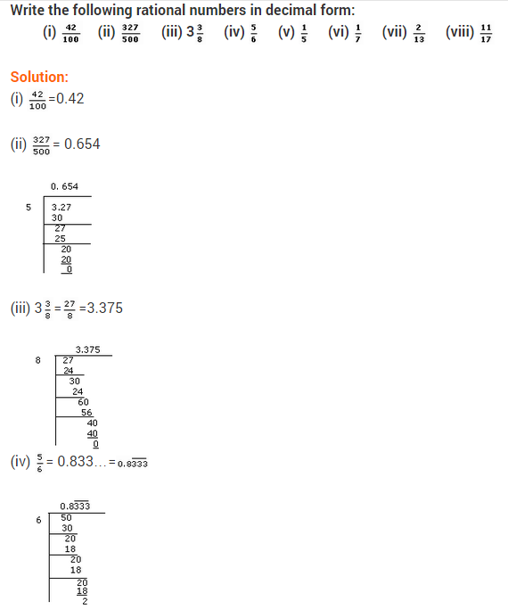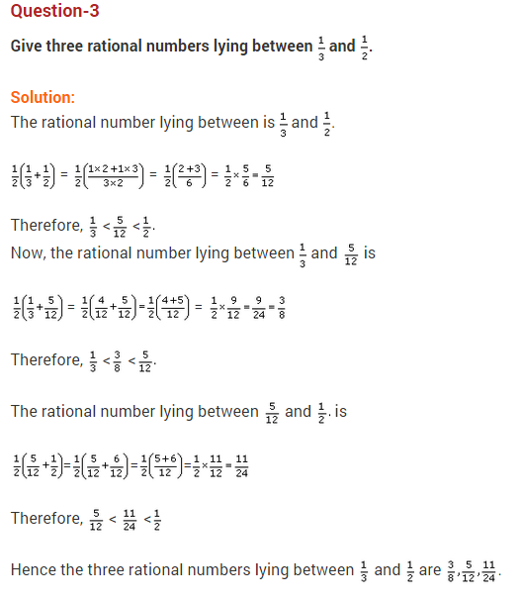  
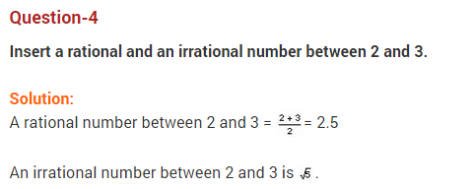  
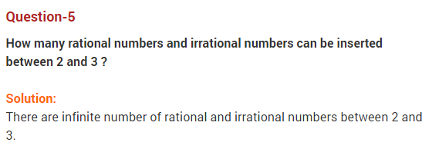  
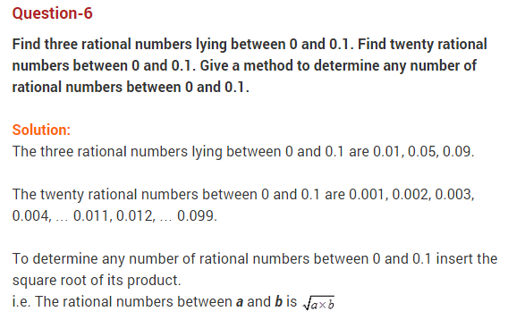  
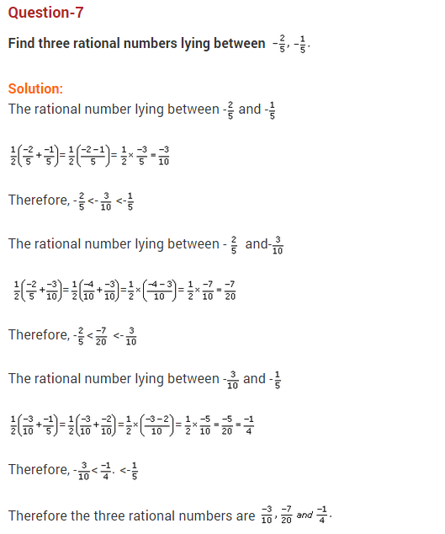  
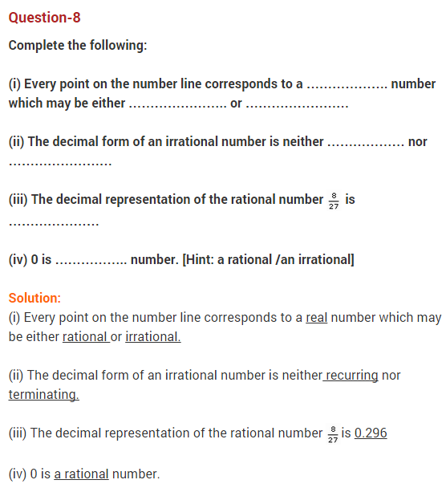  
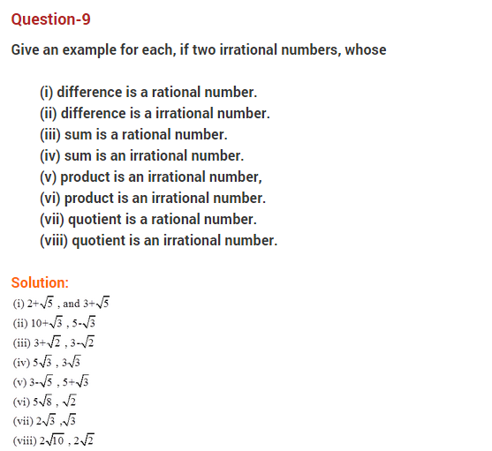  
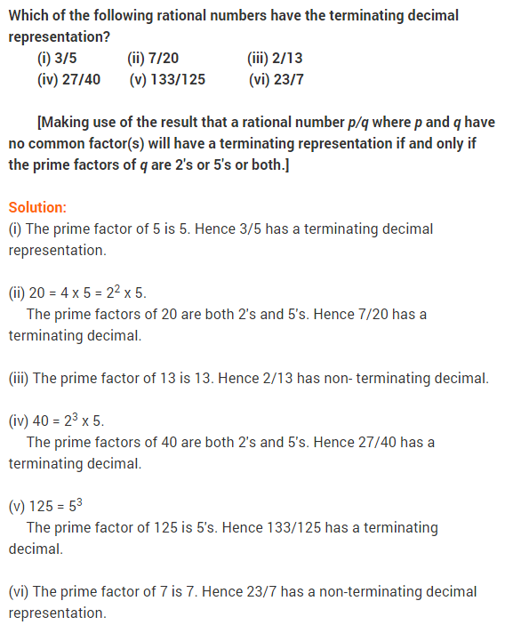  
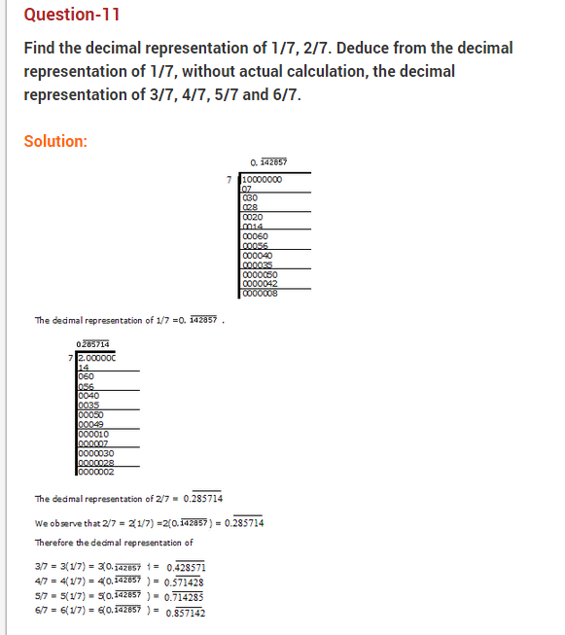  
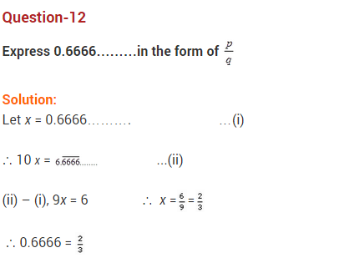  
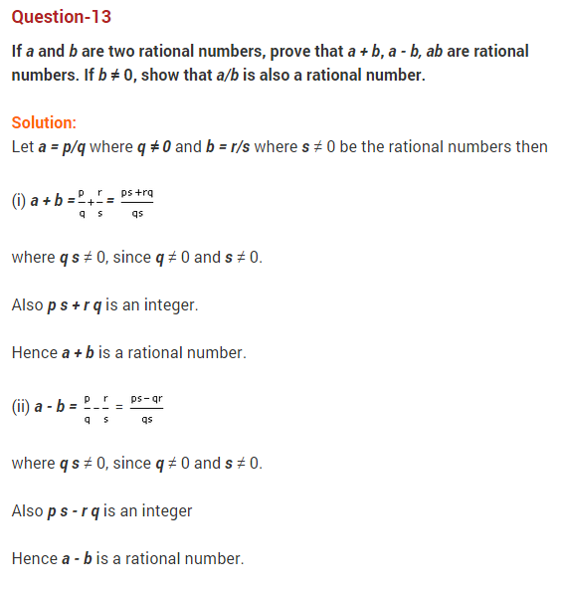  
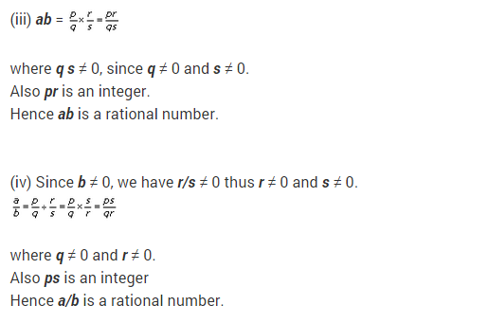  
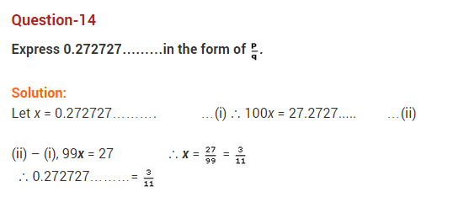  
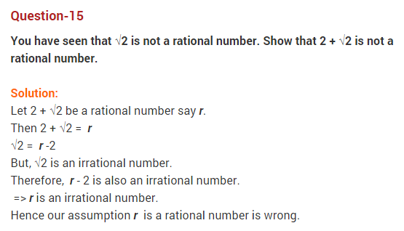  
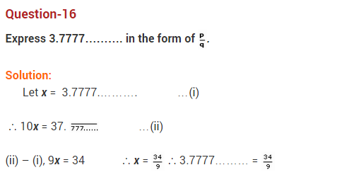  
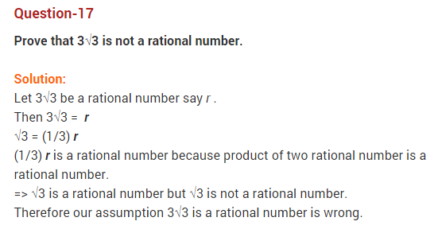  
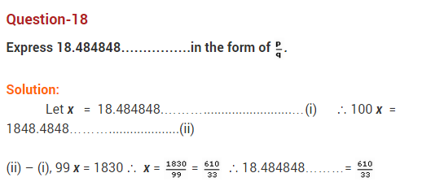  
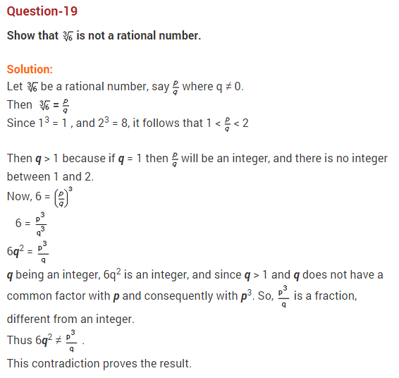  
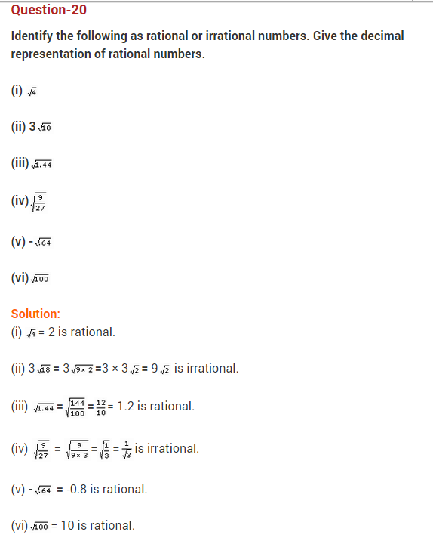  
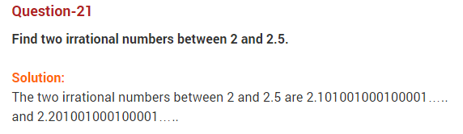  
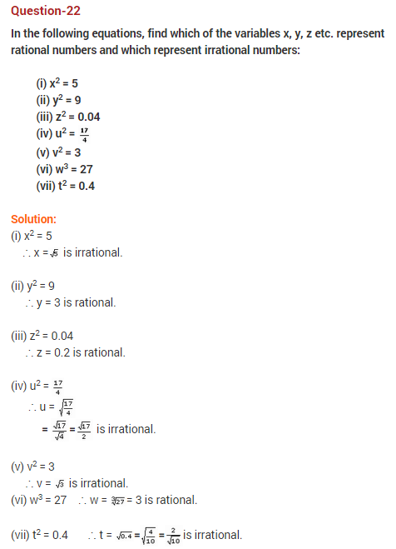  
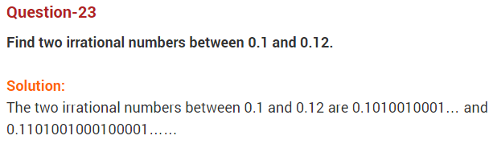  
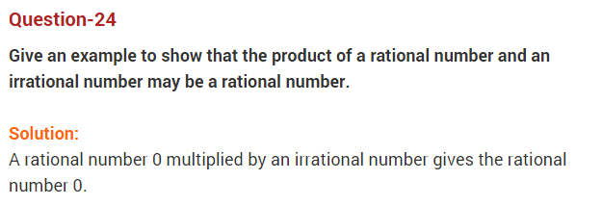  
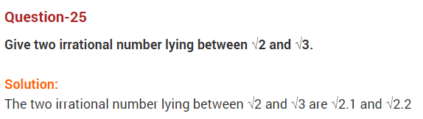  
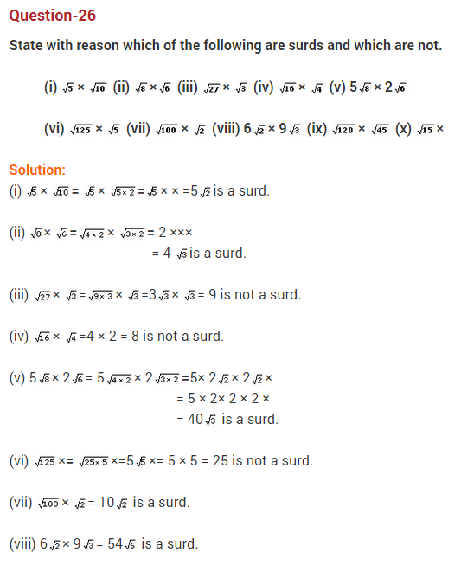  
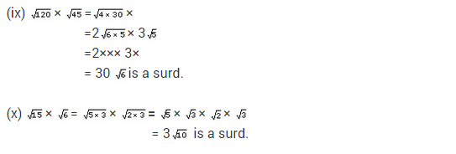  
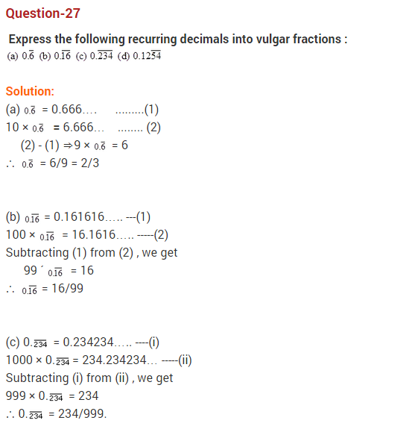  
  
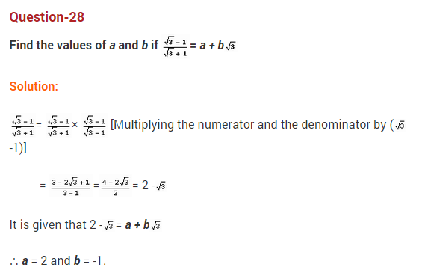  
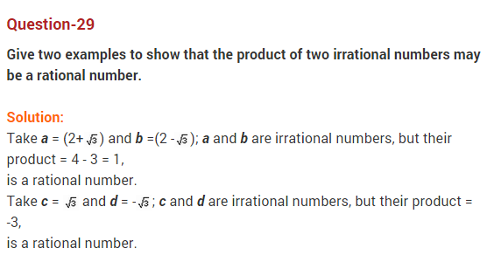  
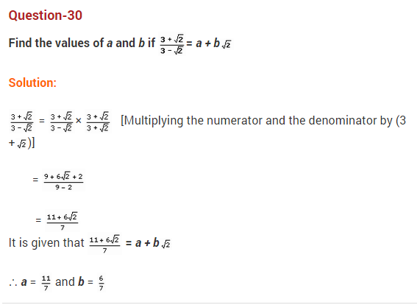  
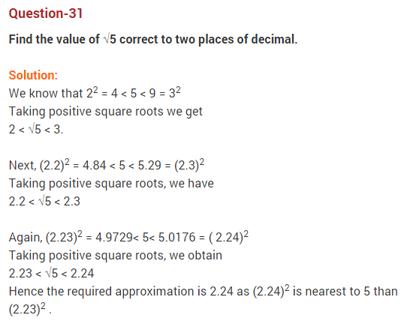  
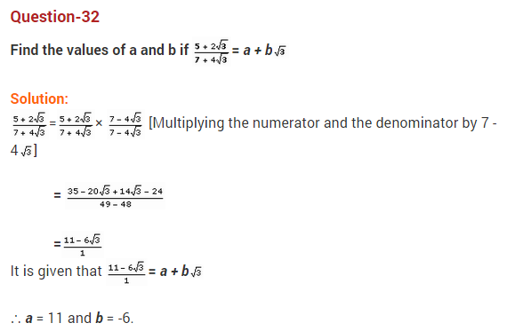  
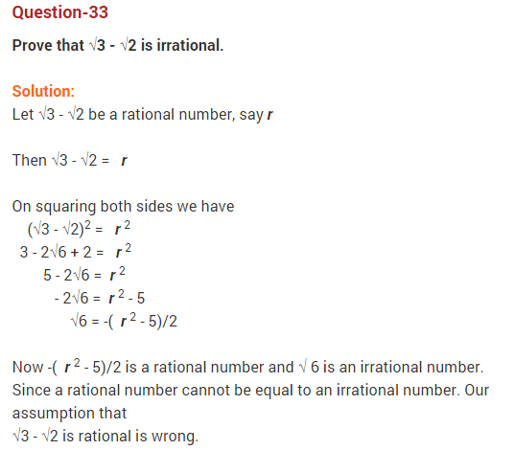  
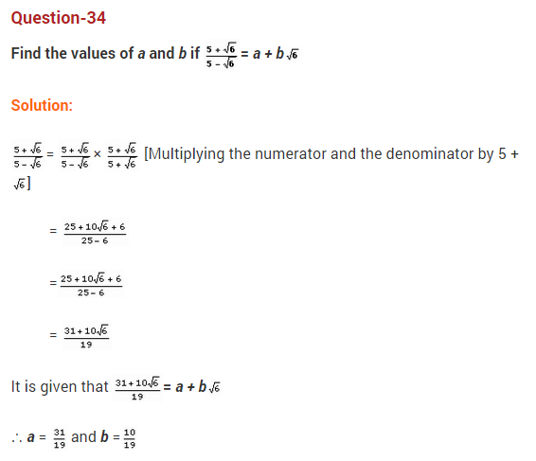  
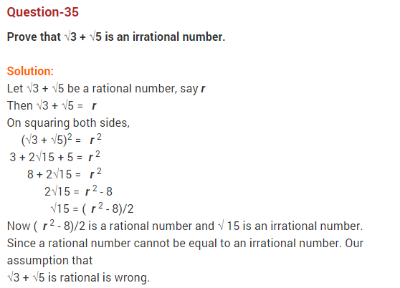  
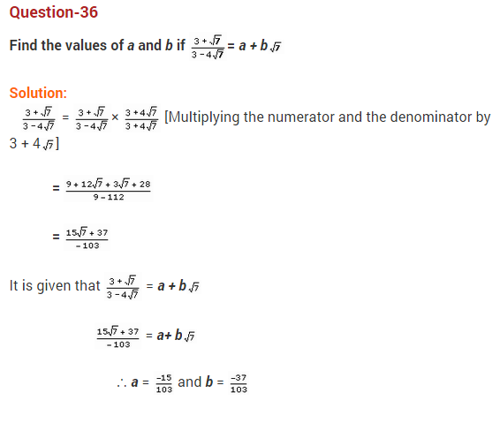  
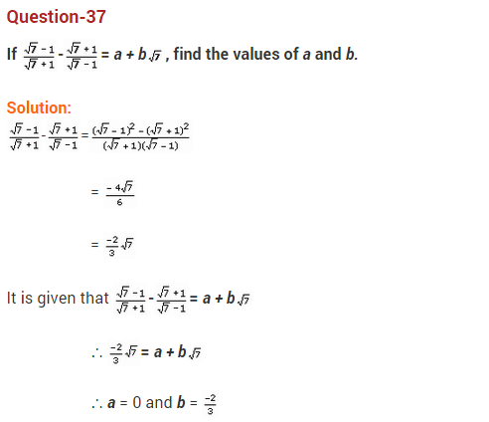  
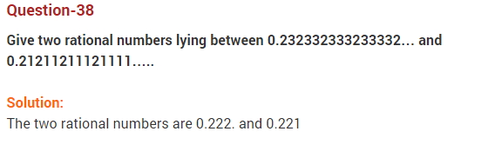  
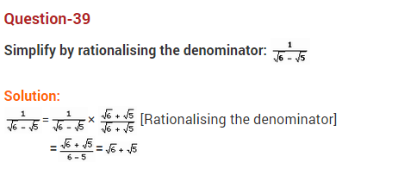  
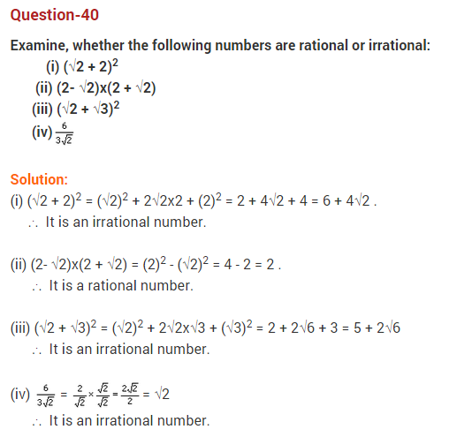  
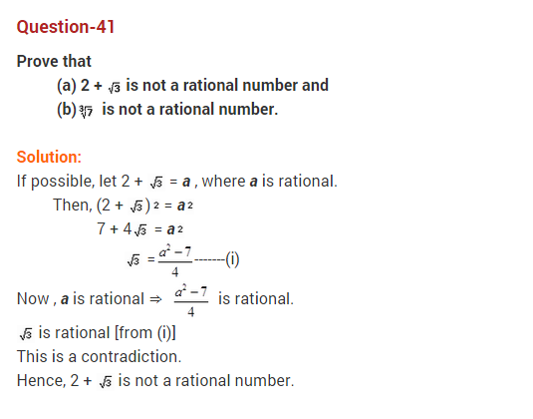  
  
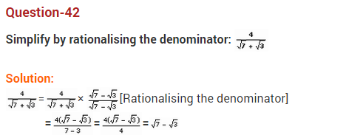  
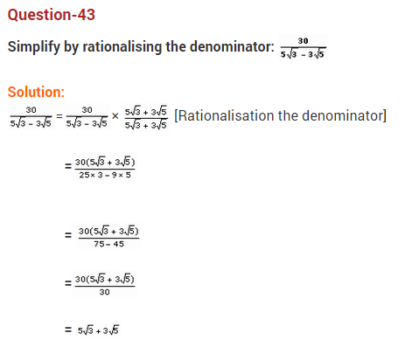  
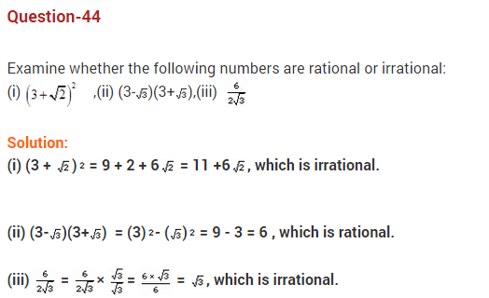  
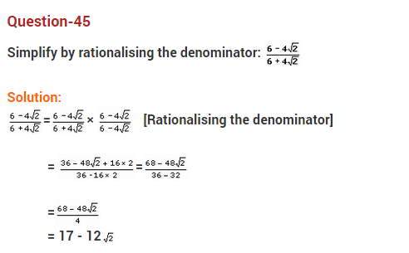  
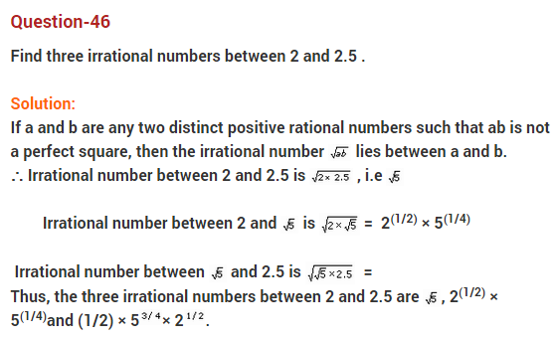  
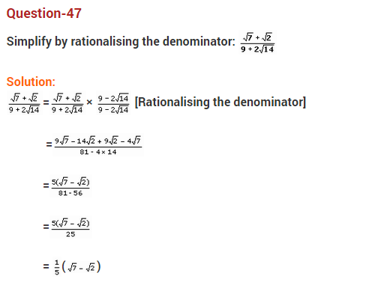  
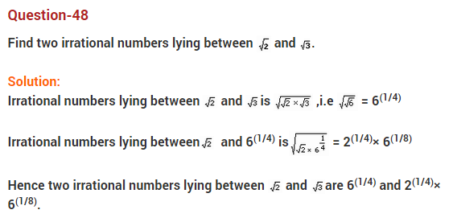  
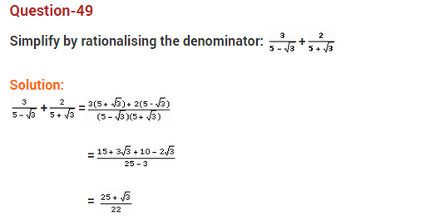  
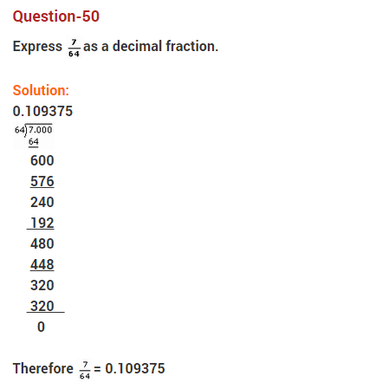  
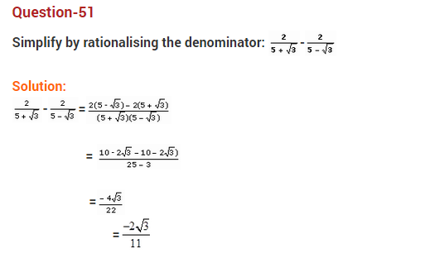  
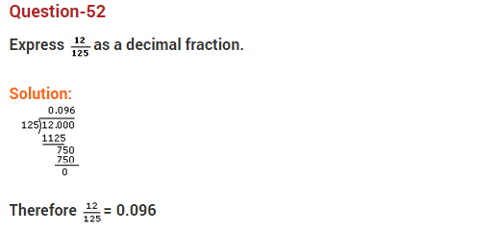  
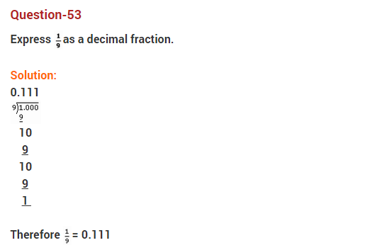  
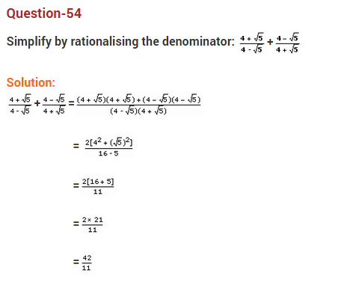  
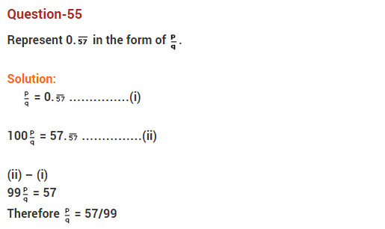  
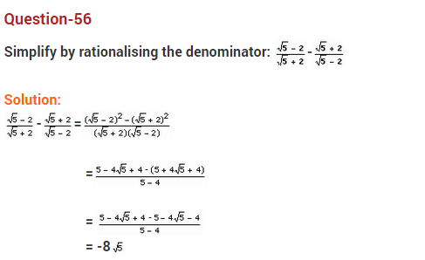  
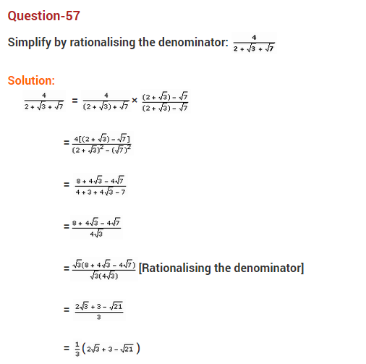  
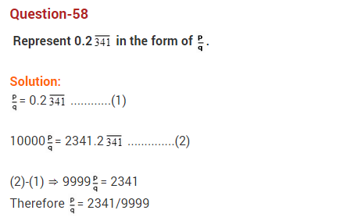  
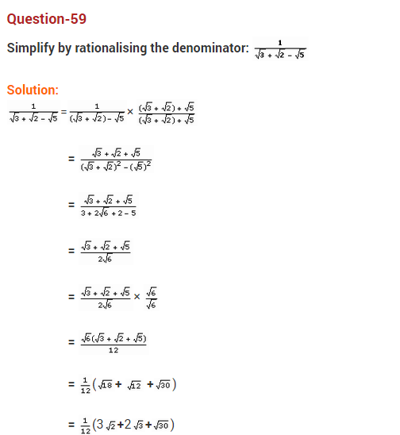  
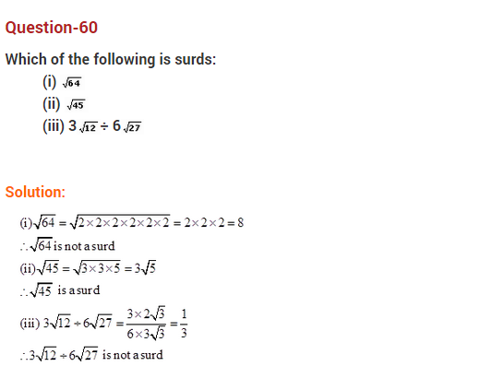  
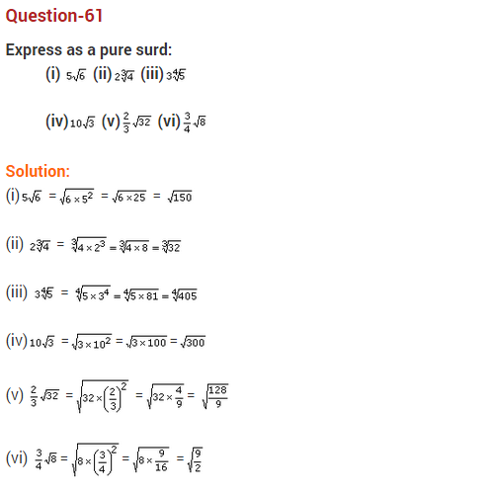  
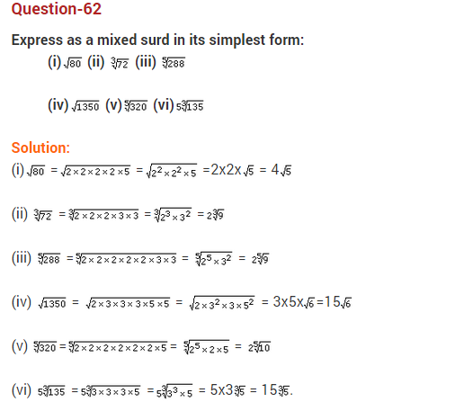  
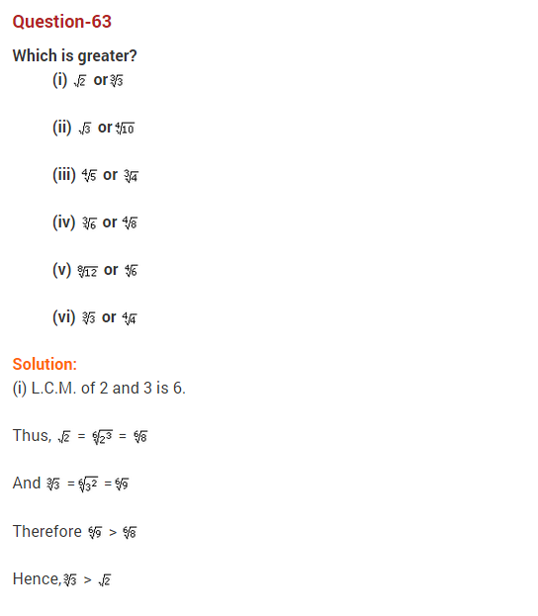  
  
  
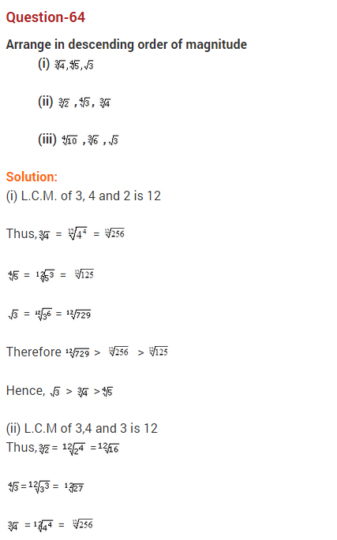  
  
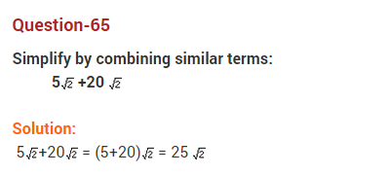  
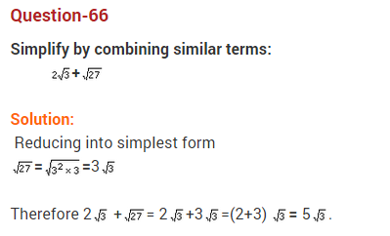  
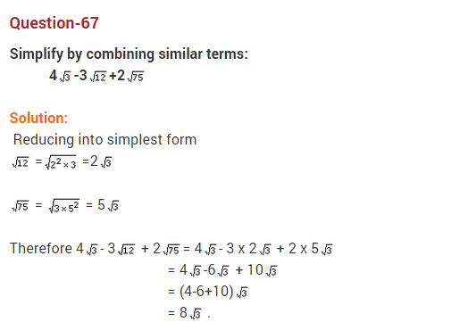  
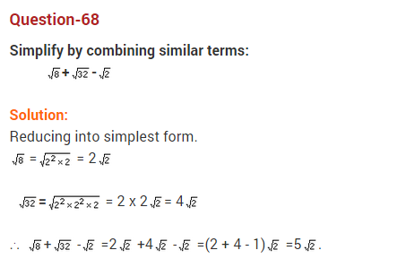  
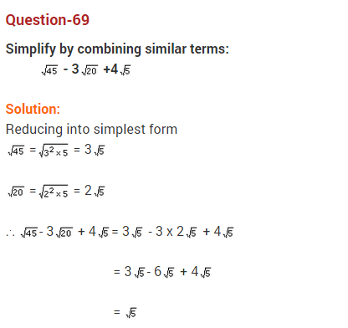  
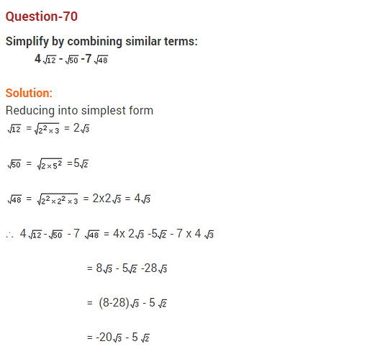  
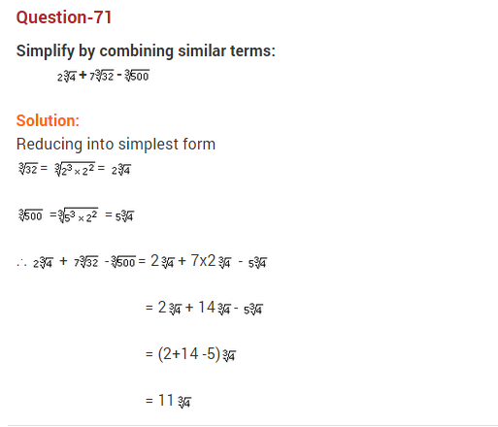  
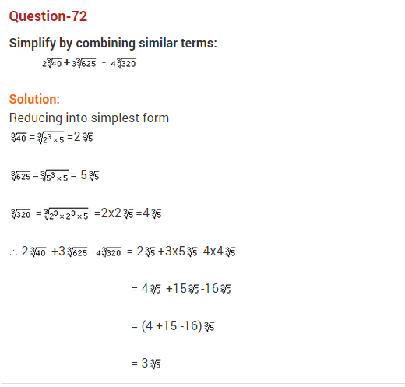  
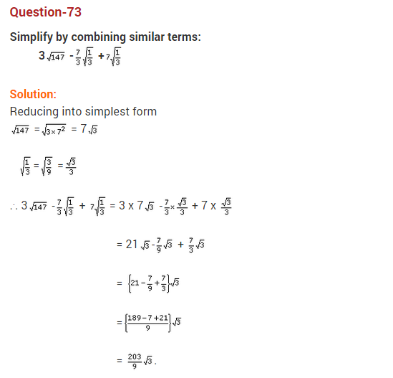  
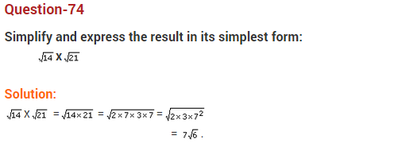  
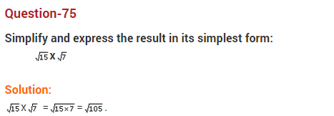  
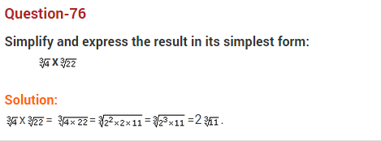  
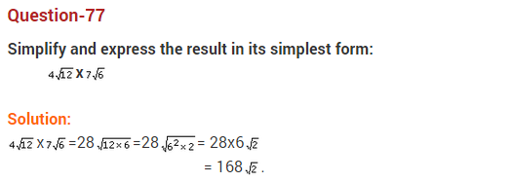  
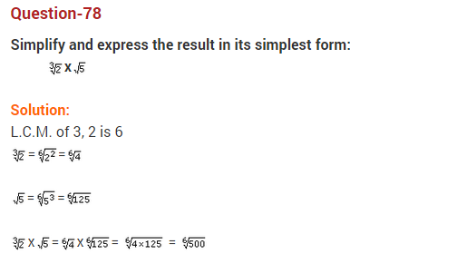  
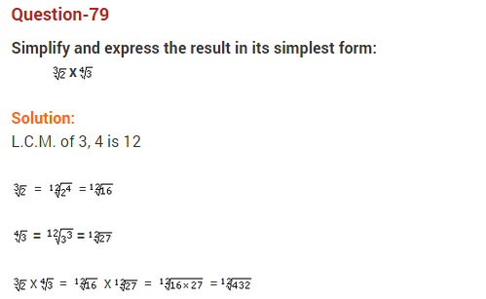  
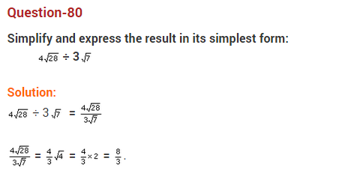  
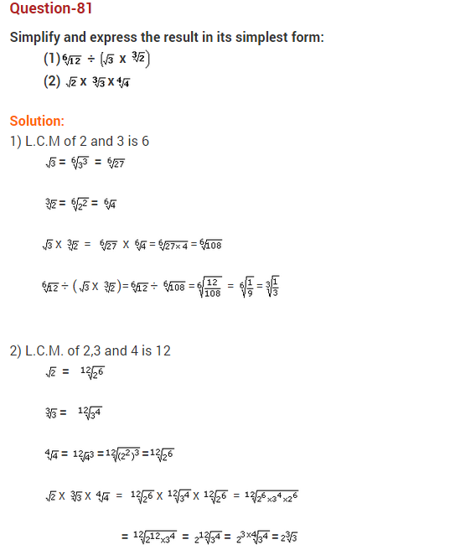  
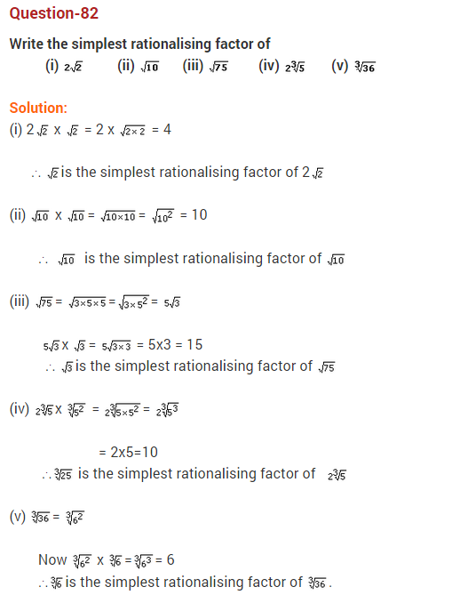  
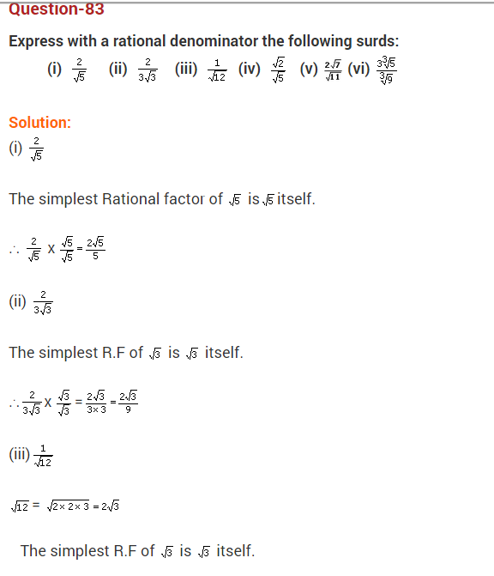  
  
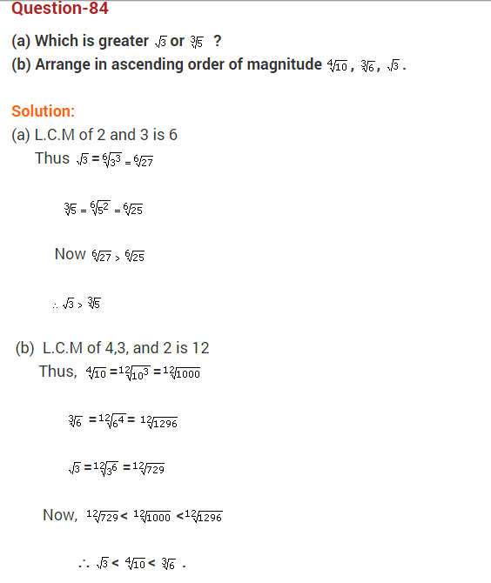  
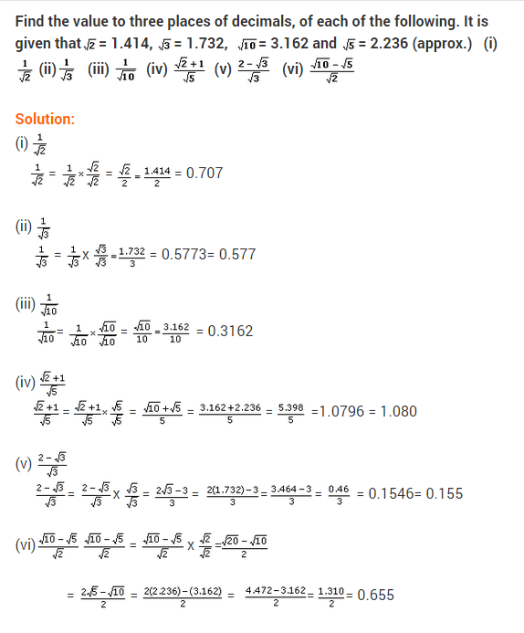  
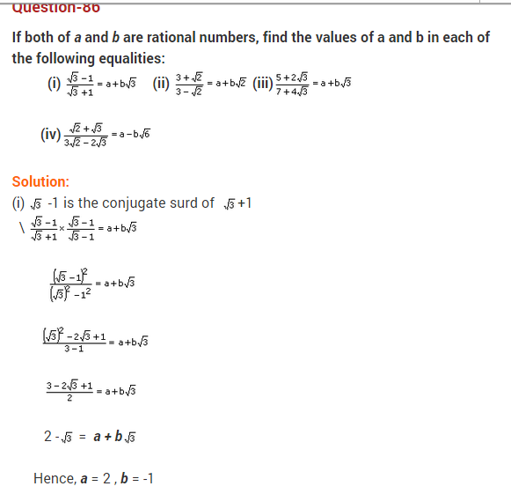  
  
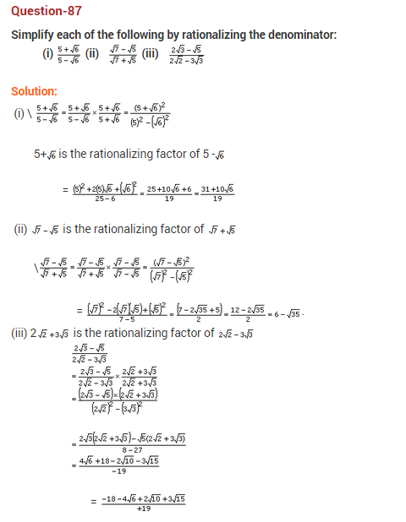  
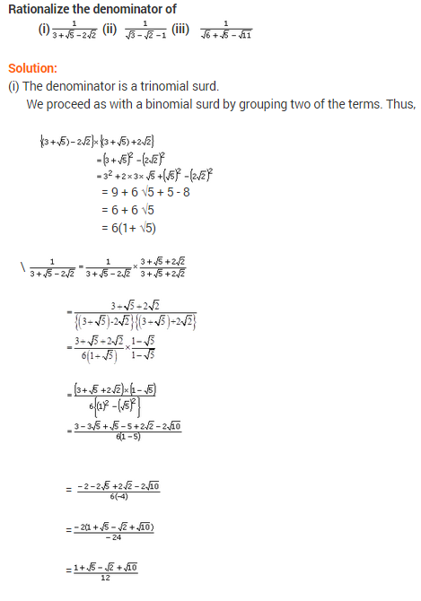  
  
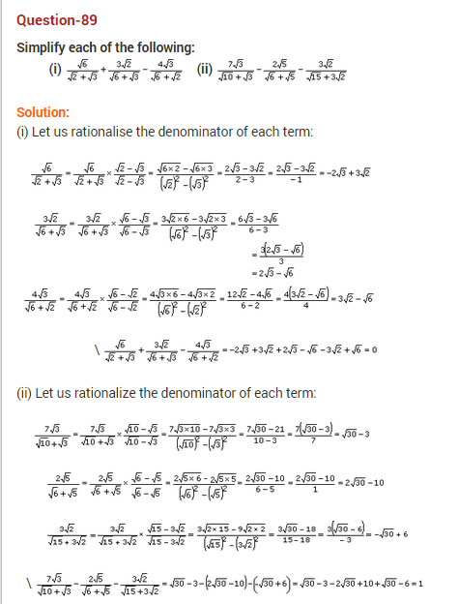  
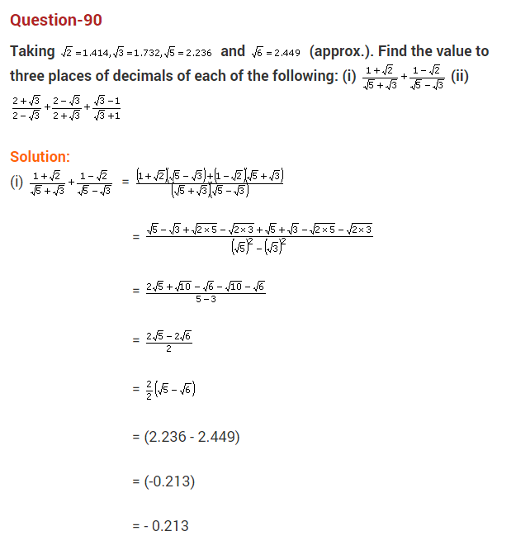  
  
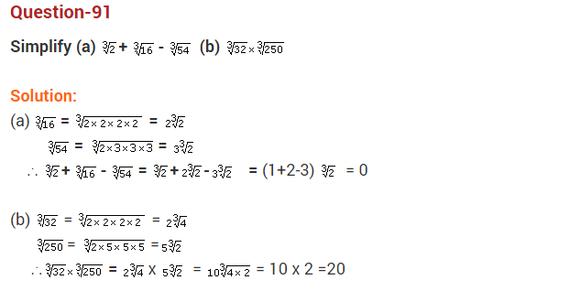  
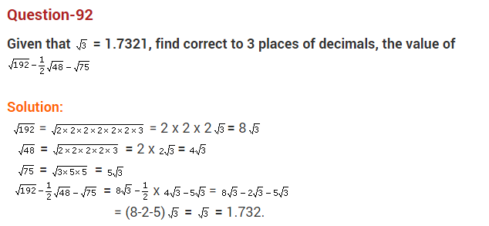  
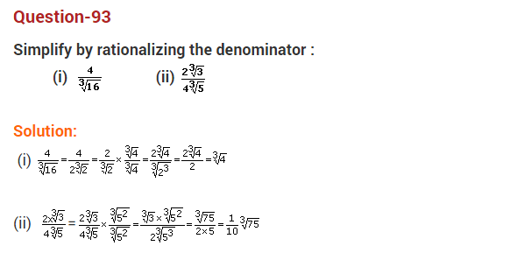  
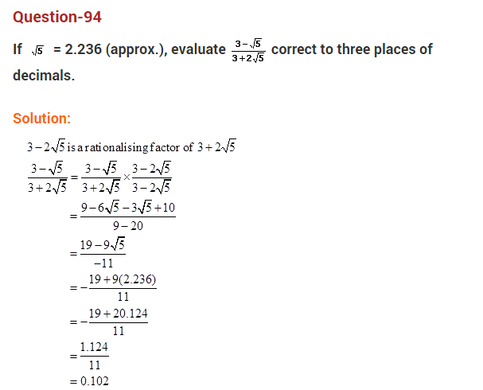  
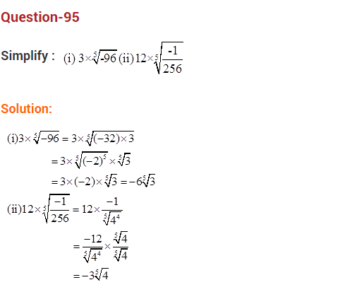  
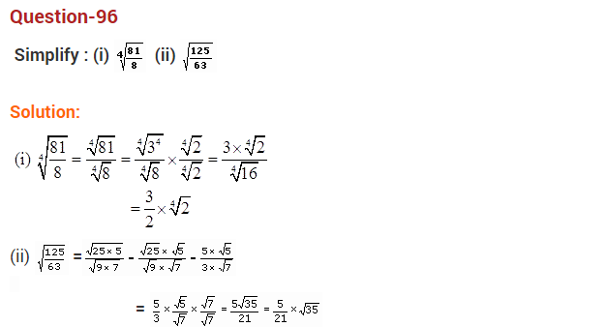  
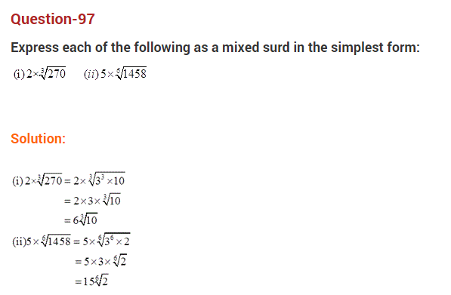  
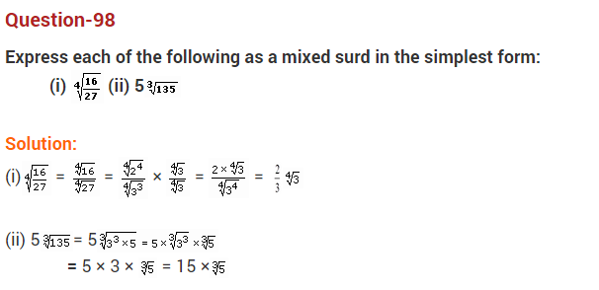  
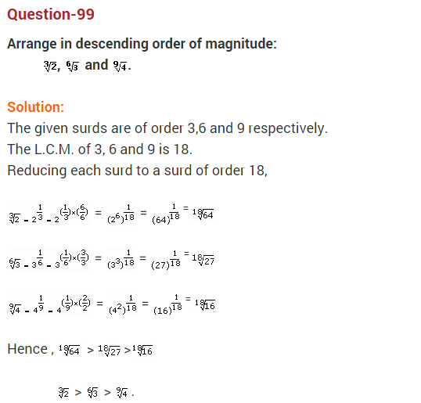  
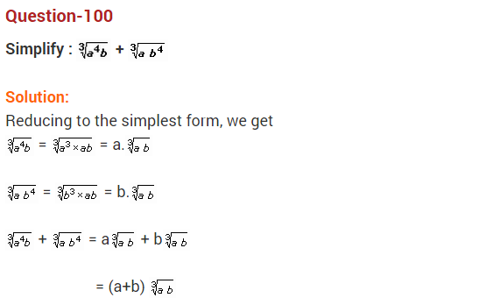  
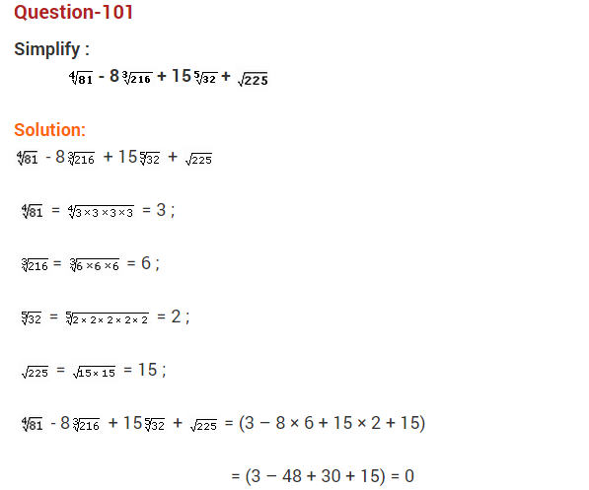  
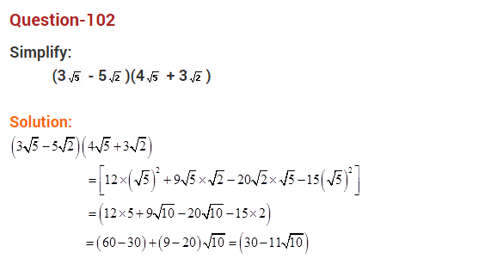  
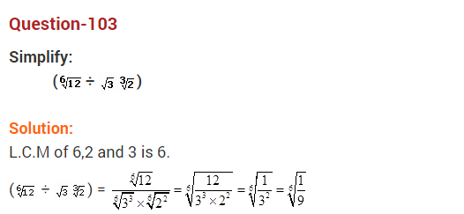  
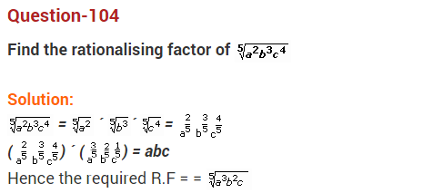  
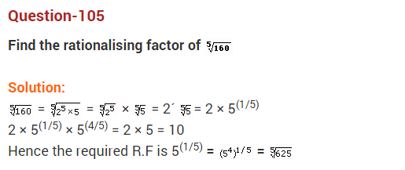  
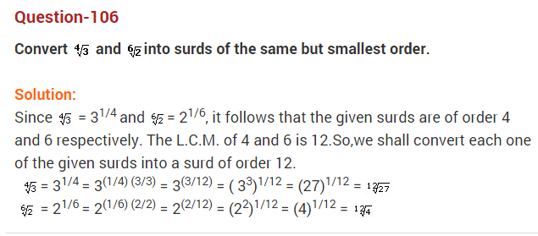  
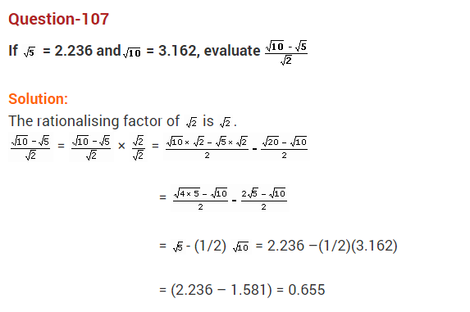  
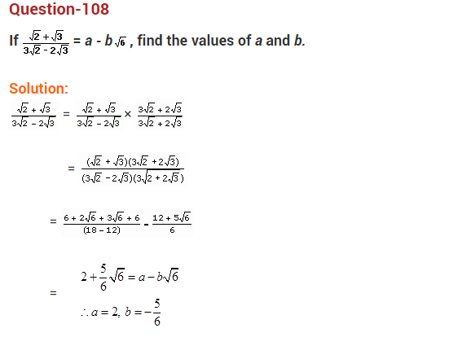  
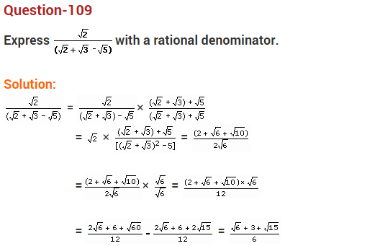  
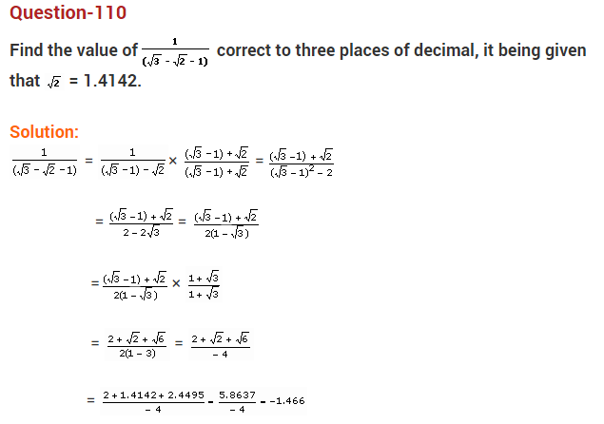

****Q.111:**** Find five rational numbers between 1 and 2.

****Q.112:**** Find five rational numbers between 3/5 and 4/5.

****Q.113:**** Locate √3 on the number line.

****Q.114:**** Are the square roots of all positive integers irrational? If not, give an example of the square root of a number that is a rational number.

****Q.115:****Find the decimal expansions of 10/3, 7/8 and 1/7.

Q.116:Show that 0.3333…=0.3¯ can be expressed in the form p/q, where p and q are integers and q≠0.

****Q.117:**** What can the maximum number of digits be in the repeating block of digits in the decimal expansion of 1/17? Perform the division to check your answer.

****Q.118:**** Find three different irrational numbers between the rational numbers 5/7 and 9/11.

****Q.119:**** Visualise 3.765 on the number line, using successive magnification.

****Q.120:****Add 2√2+ 5√3 and √2 – 3√3.

****Q.121:**** Simplify: (√3+√7) (√3-√7).

****Q.122:**** Rationalise the denominator of 1/[7+3√3].

****Q.123:**** Represent √(9.3) on the number line.

****Q.124:**** Simplify:

(i) 72/3.71/5  
(ii) 101/2/101/4

****Q.125:****  What is the product of a rational and an irrational number?  
a) Always an integer  
b) Always a rational number  
c) Always an irrational number  
d) Sometimes rational and sometimes irrational

****Q.126:****What is the value of (256)0.16 X (256)0.09?  
a) 4  
b) 16  
c) 64  
d) 256.25

****127.****  Every whole number is a natural number write true or false.

****128.****  If IMG_256 find the value of x2 + y2 + xy.

****129.****  If IMG_257 find the value of x2 - y2.

****130.****  Determine rational numbers p and q if  
       IMG_258

****131.****  Simplify: IMG_259

****132.****  Simplify: IMG_260

****133.****  Show that: IMG_261

****134.****  If: IMG_262 then find the value of qx2 – 2px + q.

****135.****  Show that: IMG_263

****136.****  If 2a = 3b = 6c then show that IMG_264

****137.****  If IMG_265 then find the value of IMG_266

****Question 138.****Simplify: (√5 + √2)2.

****Question 139.****Identify a rational number among the following numbers : 2 + √2, 2√2, 0 and π

Solution: O is a rational number.

****Question 140.****Express 1.8181… in the form pq where p and q are integers and q ≠ 0.

****Question 141.****Simplify : √45 – 3√20 + 4√5

****Question 142.****Evaluate : (√5 + √22 + (√8 – √5)2

****Question 143.****

Express 23.43¯¯¯¯¯ in pq form, where p, q are integers and q ≠ 0.  
****Question 144.****

Let ‘a’ be a non-zero rational number and ‘b’ be an irrational number. Is ‘ab’ necessarily an irrational ? Justify your answer with example.

****Question 145.****Express 1.32 + 0.35 as a fraction in the simplest form.

****Question 146.****Find ‘x’, if 2x-7 × 5x-4 = 1250.

****Question 147: Is zero a rational number? Can you write it in the form p/q, where p and q are integers and q ≠ 0?****

****Question 148: Find five rational numbers between 1 and 2.****

****Question 149: Find six rational numbers between 3 and 4.****

****Question 150: Find five rational numbers between 3/5 and 4/5.****

****Solution:****

****Question 151: Are the following statements true or false? Give reasons for your answer.****

****(i) Every whole number is a natural number.****

****(ii) Every integer is a rational number.****

****(iii) Every rational number is an integer.****

****(iv) Every natural number is a whole number,****

****(v) Every integer is a whole number.****

****(vi) Every rational number is a whole number.****

### **Exercise 1.2**

****Question 152: Express the following rational numbers as decimals.  
(i) 42/100 (ii) 327/500 (iii) 15/4****

****Question 154: Look at several examples of rational numbers in the form p/q (q ≠ 0), where p and q are integers with no common factors other than 1 and having terminating decimal representations. Can you guess what property q must satisfy?****

### **Exercise 1.3**

****Question 155: Express each of the following decimals in the form p/q:****

****(i) 0.39****

****(ii) 0.750****

****(iii) 2.15****

****(iv) 7.010****

****(v) 9.90****

****(vi) 1.0001****

****Question 156: Express each of the following decimals in the form p/q:****

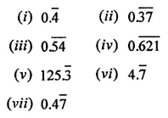

### **Exercise 1.4**

****Question 157: Define an irrational number.****

****Question 158: Explain how irrational numbers differ from rational numbers.****

****Question 159: Examine whether the following numbers are rational or irrational:****

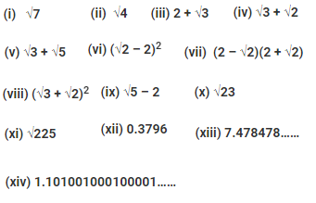

****Question 160: Identify the following as rational or irrational numbers. Give the decimal representation of rational numbers:****

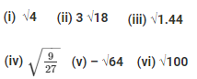

****Question 161: In the following equation, find which variables x, y, z etc. represent rational or irrational numbers:****

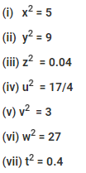

****Question 162: Represent √6, √7, √8 on the number line.****

****Question 163: Represent √3.5, √9.4, √10.5 and on the real number line.****

****Question 164: Find whether the following statements are true or false:****

****(i) Every real number is either rational or irrational.****

****(ii) π is an irrational number.****

****(iii) Irrational numbers cannot be represented by points on the number line.****

### **Exercise 1.6**

****Question 165: Visualise 2.665 on the number line using successive magnification.****

****Question 166: Visualise the representation of 5.37̅ on the number line up to 5 decimal places, that is up to 5.37777.****